Module 4

Assignment 4.2
Course: CSD402-340A Java for Programmers
Prepared By: Mirach Erkol
Date of Report: 2/1/2025

https://github.com/Mikey5007/csd-402.git

4.2 Assignment:
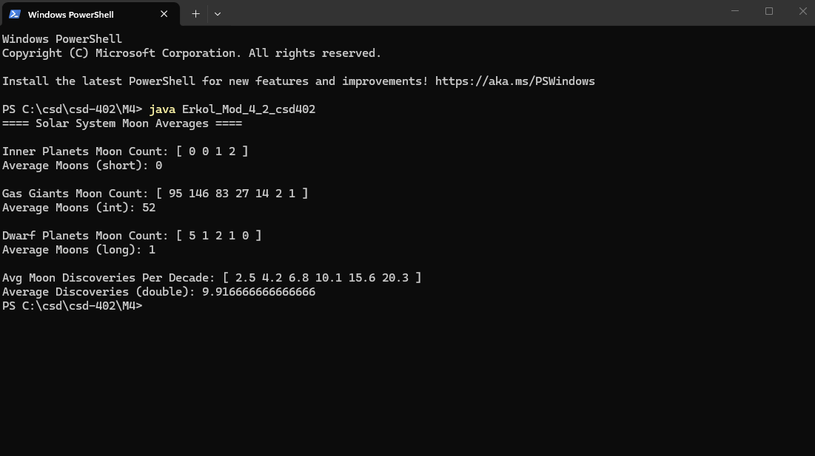

References:

https://github.com/Mikey5007/csd-402.git

